Obtaining Test Eth

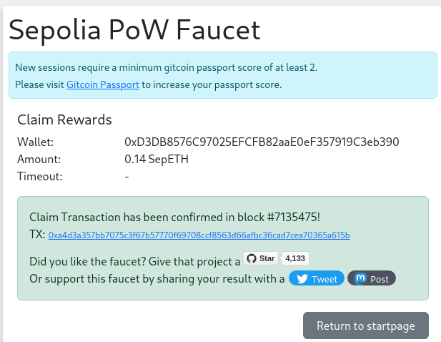

Sending first transaction on Sepolia Network

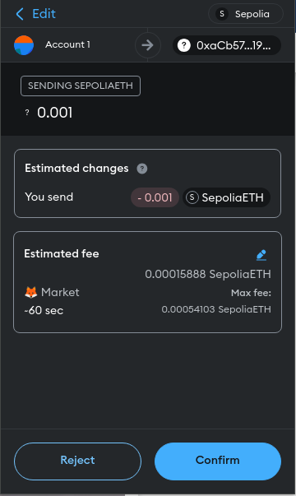

Configuring Truffle project

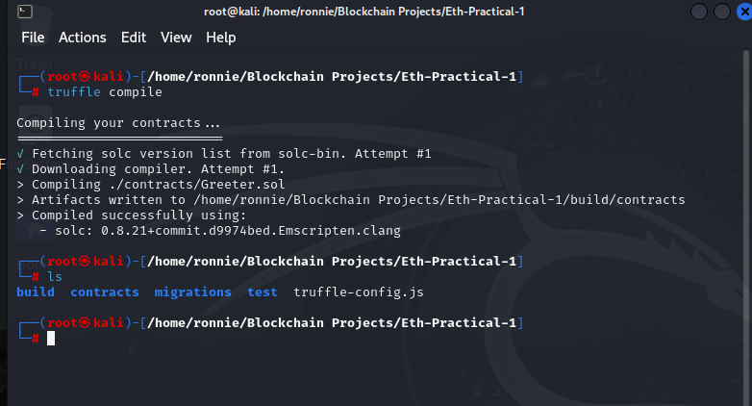

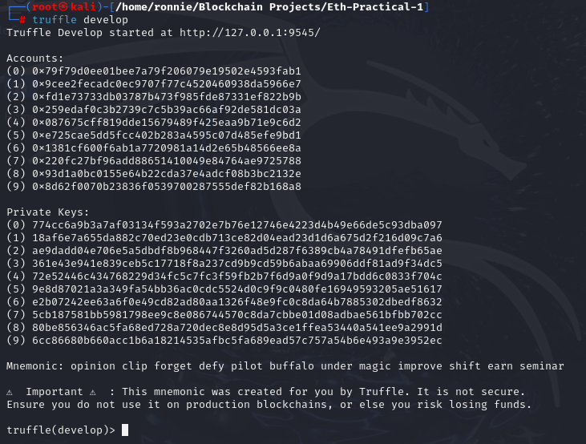

Deploying Smart contract on local ganache network (Development network)

Deploying Smart contract on Sepolia Network

